# Name: Shyam Lokhande

**Roll no: 036**

# Branch: TE Computer Batch: T1

**Assignment No : 3 Title:** GOMS model

**Problem Statement**: Implement GOMS modelling technique to model user’s behavior in given scenario

# Learning Objectives:

* Usability assessment of a given interface
* Model user behavior in terms of GOMS (Goals, Operators, Methods and Selection rules)
* Learn how to predict steps/time it will take a user to carry out a goal using GOMS Model.

# Learning Outcomes:

* Improve human-computer interaction efficiency by eliminating useless or unnecessary

interactions.

* Using GOMS modelling for usability information when the system is in the earliest of design phases.
* Improve the performance of a cognitive skill, eliminate unnecessary operators from the method used to do the task.
* Provides hierarchical task description for a specific activity.

# Requirements:

Specific scenario of user-interaction

# Theory:

Goals, operators, methods, and selection rules is a method derived from human- computer interaction (HCI) and constructs a description of human performance. The level of granularity will vary based on the needs of the analysis.

* The **Goal** is what the user wants to accomplish.
* The **Operator** is what the user does to accomplish the goal.
* The **Method** is a series of operators that are used to accomplish the goal.
* **Selection** rules are used if there are multiple methods, to determine how one was selected over the others.

# Implementing GOMS for given Scenario applicable to Assignment 1 GUI

Define the User’s Top-Level Goal

# Goal: To access user profile

**Operator:**

The user will be directed to User Profile from home page. The user requires mainly three taps to achieve the goal. First when we open the application then we go to home page from home page we need to first select menu icon at top left corner and then in the menu list there are many options. Then select Profile option and User Profile page is opened which contains information related to it.

# Methods:

1. Default: By Clicking or tapping on the Profile button present in menu list

# Selection:

Based on time taken to achieve the goal, select the appropriate method.

Rule1: User can directly tap on Profile. It is most efficient method as button is directly visible.

# Example:

(User Interface 1I image)

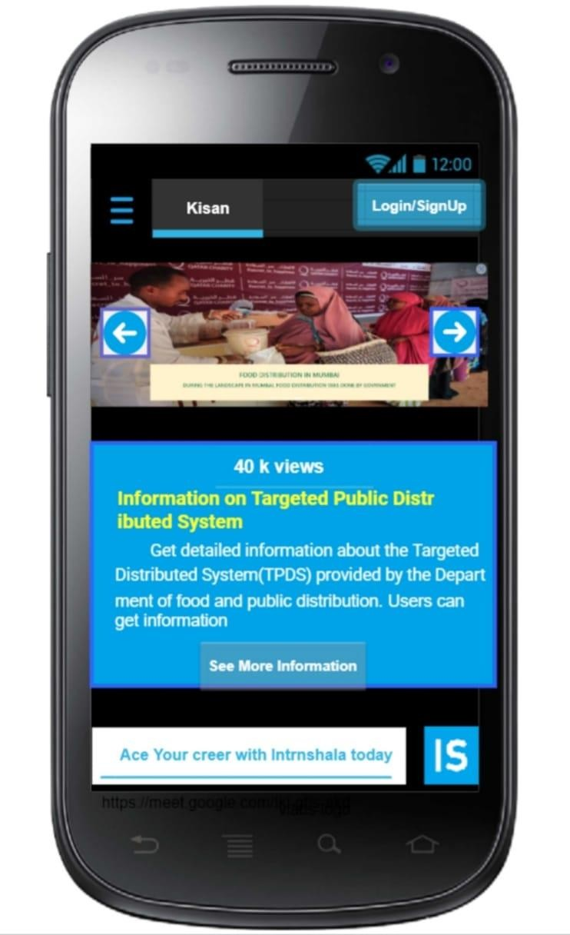

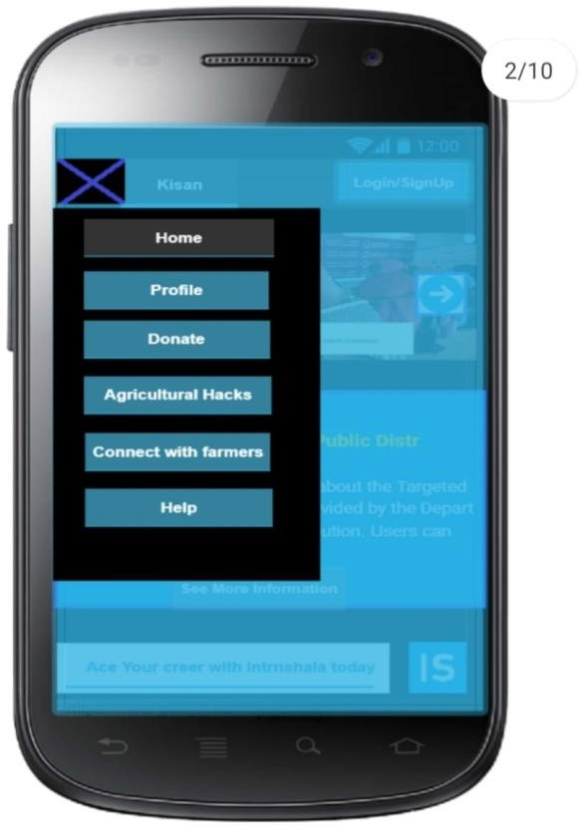

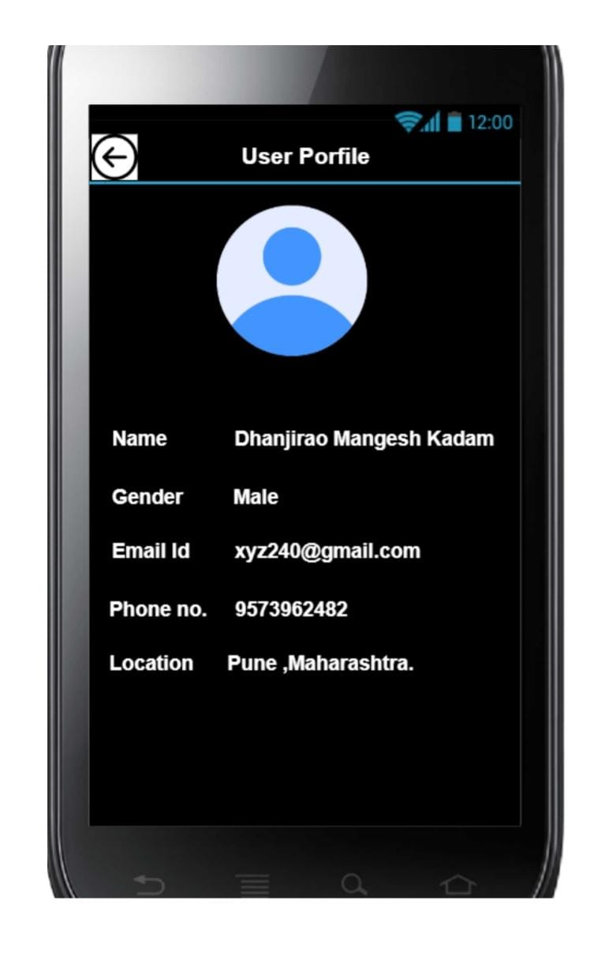

**GOAL**: Access profile

. [**select** GOAL: DEFAULT **METHOD**

. TAP ON APPLICATION ICON ON DEVICE

. TAP ON MENU ICON ON TOP LEFT CORNER FROM HOMEPAGE

. TAP ON PROFILE BUTTON

. SCROLL DOWN TO VIEW INFORMATION OF MORE FRAMERS.

**Selection** For a particular user: (Define the set of rules)

**Rule 1: Select DEFAULT METHOD** If the network speed is good and icon or image is visible then use this method

User Interface 2

Define the User’s Top-Level Goal

# Goal: To view statistical data page

**Operator:**

The user will be directed to Statistical Data page from home page. The user requires mainly three taps to achieve the goal. First when we open the application by tapping on the application icon then we go to home page. From home page we need to first select menu icon at top left corner and then in the menu list there are many options. Then select About Us option and About Us page is opened which contains information related to it. Scroll down to the end of about us page, we will see statistical data page.

# Methods:

* 1. Default Method: By clicking or tapping on the About Us button on homepage. It will display About Us page from there scroll down to see Statistical Data Page.

# Selection:

Based on time taken to achieve the goal, select the appropriate method.

Rule1: User can directly tap on the About Us button and scroll down . It is most appropriate method.

# Example:

(User Interface 2I image)

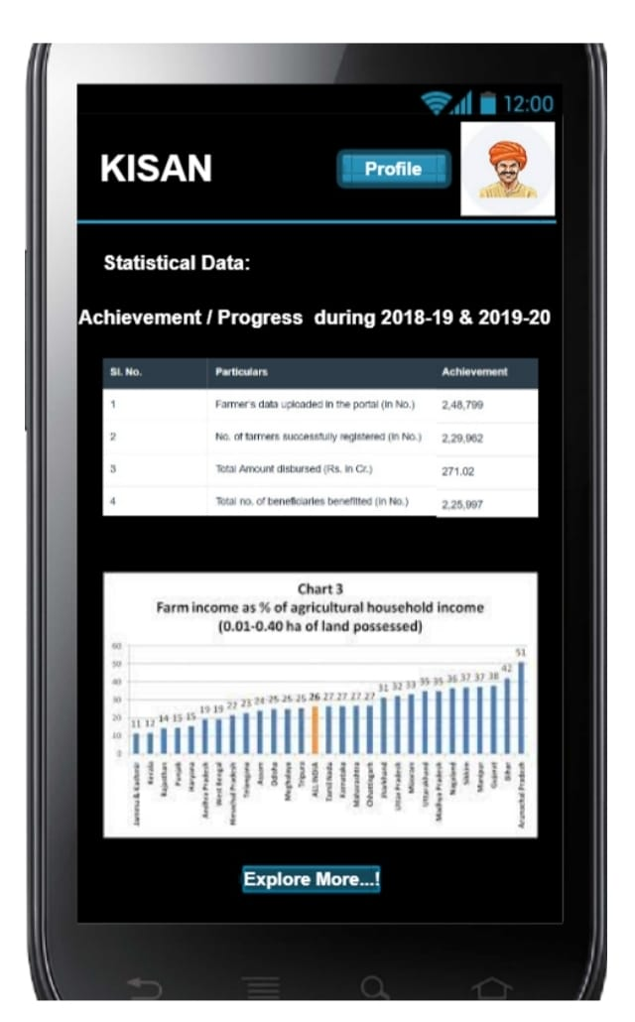

**GOAL**: Access Farmer’s Profile

. [**select** GOAL: USE-DEFAULT-**METHOD ]**

. TAP ON APPLICATION ICON ON DEVICE

. TAP ON MENU OPTION FROM HOMEPAGE

. TAP ON CONNECT WITH FRAMERS BUTTON

. TAP ON SEE PROFILE BUTTON ON CONNECT WITH FRAMERS PAGE

**Selection** For a particular user: (Define the set of rules)

**Rule 1: Select-Default -METHOD** It is method through which has easy access of Statistical Data by clicking on About Us button and scrolling down.

**Conclusion :** GOMS is a model of human performance and it can be used to improve human- computer interaction efficiency by eliminating useless or unnecessary interactions. In both the above functionalities, GOMS model helps the user to navigate and perform required operations successfully and conveniently, without making any errors. It helps users in understanding what action to be taken to achieve requirements to access from application.